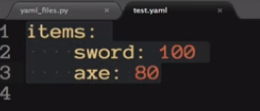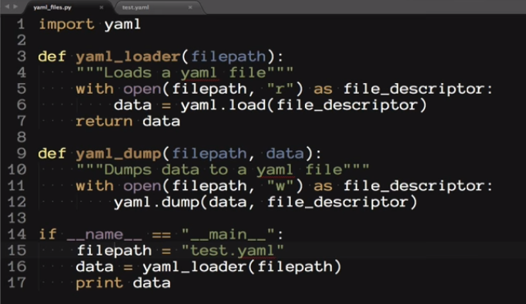Yaml in python.

They are either in .yml or .yaml



To make comments just use a Hashtag, #.

To define something simple like name you can use:

name: “mike”.

You can assign Booleans, dates, variables..

You can define attributes to a specific object. For instance, the way person is described below.

Indentation is very important. We can also create sub-lists. If I wanted to add Hiking is an attribute for person I can do a couple different things.

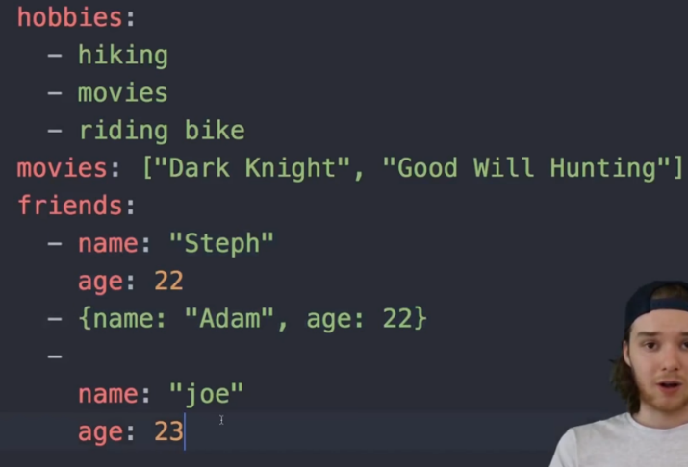

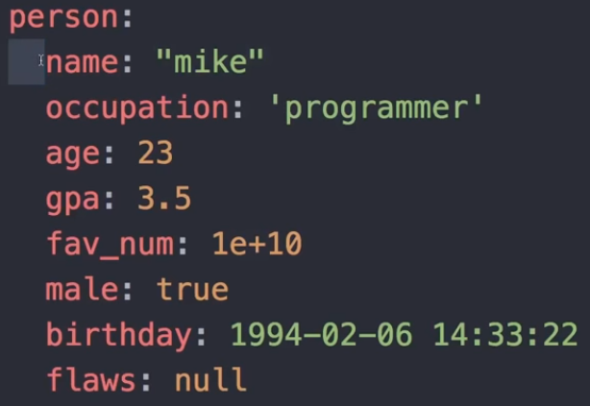

If I wanted to convert a number like 23 for age into a float, I can do:

age: !!float 23 #23.0 !!str works to turn things into strings too.

If I wanted to store a variable such as name I add just one word. Check out the example below:

name: &name “mike”

So later if I wanted the ID to match the name, I can do:

id: \*name #mike would come up.